**Vulnerability Assessment Report**

**For**



**KTC_Mobile**

**April 07, 2022**

**Document Security Level:** Confidential

**Document Version:** 1.0

|  |  |  |  |
| --- | --- | --- | --- |
| **Version** | **Date** | **Edit Report** | **Editor** |
| 1.0 | April 07, 2022 | Creation | INET Managed Services |

|  |  |  |  |
| --- | --- | --- | --- |
| KTC_Mobile | | INET Managed Services CO., LTD. | |
| Name |  | **Name** |  |
| Position |  | **Position** |  |
| Tel |  | **Tel** |  |
| Signature |  | **Signature** |  |

**Table of Contents**

1. Restrictions on disclosure and use of information 4

2. Operation Method 5

3. Project Scope 6

3.1 Infrastructure Vulnerability Assessment 6

4. Testing Tools 7

5. Infrastructure Vulnerability Assessment 7

5.1 Target Information 8

5.2 Executive summary 9

5.2.1 Summary Vulnerability by Severity 9

5.2.2 Vulnerability by Target 9

5.3 Infrastructure Vulnerability Detail 10

6. Appendix 11

6.1 About Nessus 11

6.1.1 Nessus vulnerabilities 11

6.1.2 Nessus risk score 11

6.2 About Burp Suite's web vulnerability scanner 13

6.2.1 Burp Suite's web vulnerability scanner risk score 13

# Restrictions on disclosure and use of information

Restriction on Disclosure and Use of Confidential Information. The Executive understands and agrees that the Confidential Information constitutes an asset of the Company and its affiliated entities and may not be converted to the Executive's own use. Accordingly, the Executive hereby agrees that the Executive shall not, directly, or indirectly, at any time, reveal, divulge, or disclose to any Person not expressly authorized by the Company any Confidential Information, and the Executive shall not, directly, or indirectly, use or make use of any Confidential Information in connection with any business activity other than that of the Company. The parties acknowledge and agree that this Agreement is not intended to, and does not, alter either the Company's rights or the Executive's obligations under any state or federal statutory or common law regarding trade secrets and unfair trade.

# Operation Method

* 1. Posture Review
  2. Information Gathering
  3. Enumeration
  4. Vulnerability Assessment
  5. Analyze & Evaluate Risk Value
  6. Report

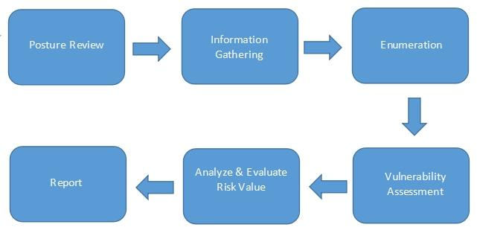

Figure 1: Operation Method

# Project Scope

## **3.1 Infrastructure Vulnerability Assessment**

**Target / IP Address:**

| **No.** | **Domain / Server Name** | **Public IP Address** | **Private IP Address** | **OS/Model** | **Functions** | **Public Assessment** | **Private Assessment** |
| --- | --- | --- | --- | --- | --- | --- | --- |
| 1 | - | - | - | - | - | - | ✓ |

# Testing Tools

|  |  |
| --- | --- |
| **Tool Name** | **Testing Type** |
| Nmap | Host and Service Discovery |
| Nessus Professional | Infrastructure Vulnerability Assessment |
| Burp Suite's web vulnerability scanner | Web Application Vulnerability Assessment |

# Infrastructure Vulnerability Assessment

**Vulnerability Assessment from Public Access (for public target)**

**Testing date:** <<Date SCAN>>

**Tester IP Address:** <<IP Target>>

Figure 2: Vulnerability Assessment from Public Access

**Vulnerability Assessment from Private Access (for private or restricted access target)**

**Testing date:** <<Date SCAN>>

**Tester IP Address:** Private IP from VPN access

Figure 3: Vulnerability Assessment from Private Access

## **5.1 Target Information**

| **No.** | **Domain / Server Name** | **IP Address** | **OS/Model** | **Port** |
| --- | --- | --- | --- | --- |
| 1 | - | 10.150.1.6 | - | TCP: 22, 25, 80, 2222, 5550, 8000, 8080, 9000, 9100, 55555 |
| 2 | - | 10.150.1.7 | - | TCP: 22, 25, 80, 3306, 5555, 7000, 9100, 9998 |
| 3 | - | 10.150.1.8 | - | TCP: 22, 25, 3306, 5555, 9100, 9998 |
| 4 | - | 10.150.1.9 | - | TCP: 22, 25, 3306, 9100, 9999 |
| 5 | - | 10.150.1.21 | - | TCP: 22, 25, 8001, 9100, 30000 |
| 6 | - | 10.150.1.24 | - | TCP: 22, 25, 9100, 30000 |
| 7 | - | 10.150.1.25 | - | TCP: 22, 25, 9100, 30000 |
| 8 | - | 10.150.1.26 | - | TCP: 22, 25, 9100, 30000 |
| 9 | - | 10.150.1.27 | - | TCP: 22, 25, 9100, 30000 |
| 10 | - | 10.150.1.28 | - | TCP: 22, 25, 9100, 30000 |
| 11 | - | 10.150.1.29 | - | TCP: 22, 25, 9100, 30000 |
| 12 | - | 10.150.1.30 | - | TCP: 22, 25, 3306, 9100, 30000 |

## **5.2 Executive summary**

The purpose of this activity is to find the vulnerability on the target infrastructure.

### **5.2.1 Summary Vulnerability by Severity**

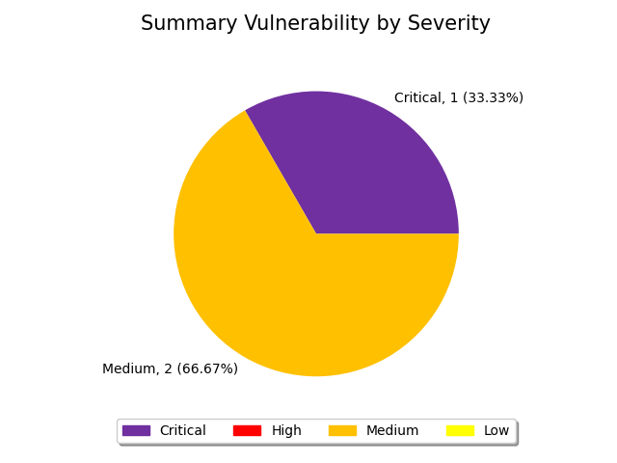

Figure 4: Summary by Severity of Infrastructure Vulnerability Assessment

### **5.2.2 Vulnerability by Target**

| **No.** | **Domain/Server Name** | **IP Address** | **Critical** | **High** | **Medium** | **Low** | **Total** |
| --- | --- | --- | --- | --- | --- | --- | --- |
| 1 | - | 10.150.1.6 | 0 | 0 | 1 | 0 | 1 |
| 2 | - | 10.150.1.7 | 0 | 0 | 0 | 0 | 0 |
| 3 | - | 10.150.1.8 | 0 | 0 | 0 | 0 | 0 |
| 4 | - | 10.150.1.9 | 0 | 0 | 0 | 0 | 0 |
| 5 | - | 10.150.1.21 | 1 | 0 | 1 | 0 | 2 |
| 6 | - | 10.150.1.24 | 0 | 0 | 0 | 0 | 0 |
| 7 | - | 10.150.1.25 | 0 | 0 | 0 | 0 | 0 |
| 8 | - | 10.150.1.26 | 0 | 0 | 0 | 0 | 0 |
| 9 | - | 10.150.1.27 | 0 | 0 | 0 | 0 | 0 |
| 10 | - | 10.150.1.28 | 0 | 0 | 0 | 0 | 0 |
| 11 | - | 10.150.1.29 | 0 | 0 | 0 | 0 | 0 |
| 12 | - | 10.150.1.30 | 0 | 0 | 0 | 0 | 0 |
| **Total** | | | 1 | 0 | 2 | 0 | 3 |

## **5.3 Infrastructure Vulnerability Detail**

|  |  |  |  |
| --- | --- | --- | --- |
| **ID.** | 1 | **Finding** | Kubernetes proxy request handling vulnerability (CVE-2018-1002105) |
| **Severity** | **Critical** | **Port** | TCP: 8001 |
| **Target** | 10.150.1.21(8001) | | |
| **Detail** | A remote, unauthenticated attacker may be able to leverage API calls  to escalate privileges via proxy request handling vulnerability.  Note that a successful attack requires that an API extension server is directly accessible from the Kubernetes API server's network or that a cluster has granted pod exec, attach, port-forward permissions too loosely. | | |
| **Solution** | Upgrade to Kubernetes 1.10.11, 1.11.5, 1.12.3 or later. | | |
| **Remark** | http://www.nessus.org/u?24a13549 http://www.nessus.org/u?98c83f19 http://www.nessus.org/u?ec479a99 http://www.nessus.org/u?e1cc1943 https://github.com/kubernetes/kubernetes/issues/71411 | | |

|  |  |  |  |
| --- | --- | --- | --- |
| **ID.** | 2 | **Finding** | SSL Certificate Cannot Be Trusted |
| **Severity** | **Medium** | **Port** | TCP: 6443 |
| **Target** | 10.150.1.21(6443) | | |
| **Detail** | The server's X.509 certificate cannot be trusted. This situation can occur in three different ways, in which the chain of trust can be broken, as stated below :   - First, the top of the certificate chain sent by the  server might not be descended from a known public  certificate authority. This can occur either when the  top of the chain is an unrecognized, self-signed  certificate, or when intermediate certificates are  missing that would connect the top of the certificate  chain to a known public certificate authority.   - Second, the certificate chain may contain a certificate  that is not valid at the time of the scan. This can  occur either when the scan occurs before one of the  certificate's 'notBefore' dates, or after one of the  certificate's 'notAfter' dates.   - Third, the certificate chain may contain a signature  that either didn't match the certificate's information  or could not be verified. Bad signatures can be fixed by  getting the certificate with the bad signature to be  re-signed by its issuer. Signatures that could not be  verified are the result of the certificate's issuer  using a signing algorithm that Nessus either does not  support or does not recognize.  If the remote host is a public host in production, any break in the chain makes it more difficult for users to verify the authenticity and  identity of the web server. This could make it easier to carry out  man-in-the-middle attacks against the remote host. | | |
| **Solution** | Purchase or generate a proper SSL certificate for this service. | | |
| **Remark** | https://www.itu.int/rec/T-REC-X.509/en https://en.wikipedia.org/wiki/X.509 | | |

|  |  |  |  |
| --- | --- | --- | --- |
| **ID.** | 3 | **Finding** | JQuery 1.2 3.5.0 Multiple XSS |
| **Severity** | **Medium** | **Port** | TCP: 8080 |
| **Target** | 10.150.1.6(8080) | | |
| **Detail** | According to the self-reported version in the script, the version of JQuery hosted on the remote web server is greater than or equal to 1.2 and prior to 3.5.0. It is, therefore, affected by multiple cross site scripting vulnerabilities.  Note, the vulnerabilities referenced in this plugin have no security impact on PAN-OS, and/or the scenarios  required for successful exploitation do not exist on devices running a PAN-OS release. | | |
| **Solution** | Upgrade to JQuery version 3.5.0 or later. | | |
| **Remark** | https://blog.jquery.com/2020/04/10/jquery-3-5-0-released/ https://security.paloaltonetworks.com/PAN-SA-2020-0007 | | |

# Appendix

## **6.1 About Nessus**

Nessus is a proprietary vulnerability scanner developed by Tenable, Inc. Nessus is trusted by more than 30,000 organizations worldwide as one of the most widely deployed security technologies on the planet - and the gold standard for vulnerability assessment.

Reference: https://www.tenable.com/products/nessus

### **6.1.1 Nessus vulnerabilities**

As information about new vulnerabilities are discovered and released into the public domain, Tenable, Inc. research staff designs programs to enable Nessus to detect them. These programs are named plugins, and are written in the Nessus proprietary scripting language, called Nessus Attack Scripting Language (NASL). Plugins contain vulnerability information, a generic set of remediation actions, and the algorithm to test for the presence of the security issue.

Reference: https://www.tenable.com/plugins

### **6.1.2 Nessus risk score**

There are four risk levels in this document: Critical, High, Medium, and Low. There are methods for determining the risk level. Based on the Common Vulnerability Scoring System (CVSS), a standard for assessing the severity of vulnerabilities in computer systems. Regarded by the NIAC (National Infrastructure Advisory Council), expert assessments are measured in a range of 0 – 10

| **Severity** | **Description** | **Score** |
| --- | --- | --- |
| Critical | Vulnerabilities that score in the critical range usually have most of the following characteristics:   * Exploitation of the vulnerability likely results in root-level compromise of servers or infrastructure devices. * Exploitation is usually straightforward, in the sense that the attacker does not need any special authentication credentials or knowledge about individual victims, and does not need to persuade a target user, for example via social engineering, into performing any special functions.   For critical vulnerabilities, is advised that you patch or upgrade as soon as possible, unless you have other mitigating measures in place. For example, a mitigating factor could be if your installation is not accessible from the Internet. | 9.0 – 10.0 |
| High | Vulnerabilities that score in the high range usually have some of the following characteristics:   * The vulnerability is difficult to exploit. * Exploitation could result in elevated privileges. * Exploitation could result in a significant data loss or downtime. | 7.0 – 8.9 |
| Medium | Vulnerabilities that score in the medium range usually have some of the following characteristics:   * Vulnerabilities that require the attacker to manipulate individual victims via social engineering tactics. * Denial of service vulnerabilities that are difficult to set up. * Exploits that require an attacker to reside on the same local network as the victim. * Vulnerabilities where exploitation provides only very limited access. * Vulnerabilities that require user privileges for successful exploitation. | 4.0 – 6.9 |
| Low | Vulnerabilities in the low range typically have very little impact on an organization's business. Exploitation of such vulnerabilities usually requires local or physical system access. | 0.1 – 3.9 |

## **6.2 About Burp Suite's web vulnerability scanner**

The web vulnerability scanner behind Burp Suite's popularity has more to it than most. Burp Scanner uses PortSwigger's world-leading research to help its users find a wide range of vulnerabilities in web applications, automatically. Sitting at the core of both Burp Suite Enterprise Edition and Burp Suite Professional, Burp Scanner is the weapon of choice for over 60,000 users across more than 15,000 organizations.

Reference: https://portswigger.net/burp/vulnerability-scanner

### **6.2.1 Burp Suite's web vulnerability scanner risk score**

The level of severity for an issue that was found by a scan. The higher the severity level, the larger the impact is likely to be if an attacker is able to exploit this vulnerability. Note that the severity level is only a rough approximation based on a typical website. You should use your knowledge of the purpose and context of the associated functionality to determine how serious each issue is in your individual case.

Reference: https://portswigger.net/burp/extensibility/enterprise/graphql-api/severity.html

| **Severity** | **Description** |
| --- | --- |
| High | An attacker can **fully** compromise the confidentiality, integrity, or availability, of a target system without specialized access, user interaction or circumstances that are beyond the attacker’s control. Very likely to allow lateral movement and escalation of attack to other systems on the internal network of the vulnerable application. |
| Medium | An attacker can **partially** compromise the confidentiality, integrity, or availability, of a target system. Specialized access, user interaction, or circumstances that are beyond the attacker’s control may be required for an attack to succeed. Very likely to be used in conjunction with other vulnerabilities to escalate an attack. |
| Low | An attacker can **limitedly** compromise the confidentiality, integrity, or availability, of a target system. Specialized access, user interaction, or circumstances that are beyond the attacker’s control is required for an attack to succeed. Needs to be used in conjunction with other vulnerabilities to escalate an attack. |